1- Installing Rails
Listing 1.1: Installing Rails with a specific version number.
$ gem install rails -v 4.2.2

Listing 1.3: Running rails new (with a specific version number).
$ cd ~/workspace
$ rails _4.2.2_ new hello_app

File/Directory | Purpose
app/ | Core application (app) code, including models, views, controllers, and helpers
app/assets | Applications assets such as cascading style sheets (CSS), JavaScript files, and images
bin/ | Binary executable files
config/ | Application configuration
db/ | Database files
doc/ | Documentation for the application
lib/ | Library modules
lib/assets | Library assets such as cascading style sheets (CSS), JavaScript files, and images
log/ | Application log files
public/ | Data accessible to the public (e.g., via web browsers), such as error pages
bin/rails | A program for generating code, opening console sessions, or starting a local server
test/ | Application tests
tmp/ | Temporary files
vendor/ | Third-party code such as plugins and gems
vendor/assets | Third-party assets such as cascading style sheets (CSS), JavaScript files, and images
README.rdoc | A brief description of the application
Rakefile | Utility tasks available via the rake command
Gemfile | Gem requirements for this app
Gemfile.lock | A list of gems used to ensure that all copies of the app use the same gem versions
config.ru | A configuration file for Rack middleware
.gitignore | Patterns for files that should be ignored by Git

The composer in Ruby is called Gemfile. Once you have customized it run
$ cd hello_app/
$ bundle install
Fetching source index for https://rubygems.org/

in order to fetch the needed gems

The gemfile

The gemfile (much like composer.json) has two parts. First it lists all gems that are being used in the project, along with their versions. Second, it specifies which gems should only be used in dev mode.
First steps

There are three steps by which you will starting

1- Defining the models and controllers in bin/rails
2- Defining the route in config.routes.rb
3- Configuring database: config/database.yml

These steps are interesting to learn because this probably is the standard procedure for most MVC frameworks.

2 – Rails Server

Rails comes in with a built in local web server that runs through the terminal. Simply type Rails server. You will then be able to access the app via http://localhost:3000

3 – Rails structure

app/

This directory comes with three subdirectories: models, views and controllers.
The structure is thus centralized in the app directory.

We will make our first hello world view by adding a controller action to render this string.

Listing controllers: ls app/controllers/*_controller.rb

We can immediately see that the structure of the controller is that of an object. Rendering text will then be implemented as a method of that class.
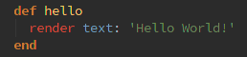
This alone is not enough. The welcome page is still the one provided by rails. To make the change effective, and replace the default template with our own version, we have to edit the Rails router (config/routes) and change the default route for “/”

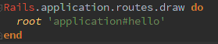
What does this line do? First 'root' is the location where the behaviour is going to be triggered. Second, between brackets, we have first the name of the controller (application) and the name of the method (hello) that we just defined in the previous screenshot.

4- Deploying

Remember uploading your first websites? In a local environement, they looked great. But when time came to upload them (aka, to put them in production)… Ugh. That's why Rails offers the possibility to deploy your app into production early on.

A good deployment option is heroku, which is a hosted platform built specifically for deploying Rails and other web apps (you need to put your source code under version control on Git girst).

Rails and databases

We are going to implement a users data model along with the corresponding web interface to that model (Whose combination is the Users ressource)
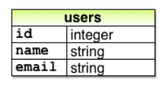

We will do this by creating a scaffold (table) in the console
=> rails generate scaffold User name:string email:string

and then
=> bundle exec rake db:migrate

Now, accessing your $root/users will bring you directly to the table page where there is some pregenerated code that allows you to create, edit and drop users.

Note: any variable that looks like this :variable is a symbol.

REST

This means Representational State Transfer. Application components (such as users) are considered as a ressource. This explains the particular way we handled creating our database in the previous point.

If you want to add validations to the microposts, do so in the model, in the microposts class
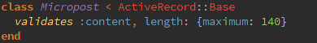
Generating Static pages

We'll start by generating a controller through the generate command.
=> rails generate controller StaticPages home help
(Static Pages is the name of the controller)

The routes are automatically updated,and so, the url static_pages/help will automatically direct to the controller method called help. It seems that there is no URL rewriting with this method.

Test-driven development

There are three types of tests: controller tests, model tests and integration tests.

Then we run
=> bundle exec rake test

Root

setting up the root file for the app: replace get with root where you want it

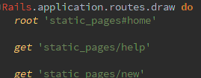
In the html, we insert ruby variable with <%= yield variable%> tags and by putting <%provide(variable)%> at the beginning of the html.

If we want to customize that yield, we are gonna use a helper script in app/helpers.

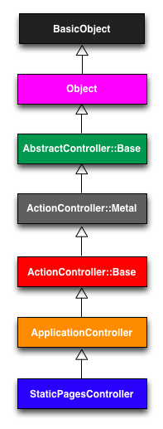
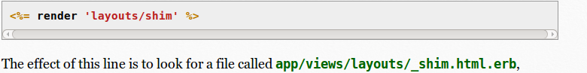

Creating a user sign-up model

We type in the console
=>rails generate model User name:string email:string

This will in turn generate a script in models and a script in db/migrate/timestamp_create_users.rb

Then we run in order to do the migration
=> bundle exec rake db:migrate

